Did you notice…?

1. Objectives

Explain how a small network of directly connected segments is created, configured and verified.

In this activity, you will note how networks differ, both in size and in function. You will identify how networks provide different networking solutions based upon their cost, speed, ports, expandability, and manageability, related to the needs of a small-to-medium-sized business.

1. Topology

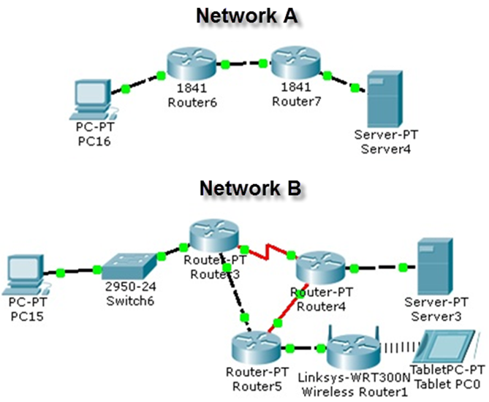

1. Background/Scenario

Using the two networks in the topology diagram as reference, answer the following questions and record your answers to share with the class.

* Visually compare and contrast Network A and Network B. How are the two networks the same?
* Make note of the devices used in each network design. Because the devices are labeled, you already know what types of end and intermediary devices they are. How are the two networks different? Is the number of devices present in one network the only differentiating factor? Justify your answer.
* Which network you would select if you owned a small-to-medium-sized business. Justify your selected network based on cost, speed, ports, expandability, and manageability.

1. Required Resources

Recording capabilities (paper, tablet, etc.) for reflective comments to be shared with the class.

1. Reflection
2. Reflect upon your comparisons of the two network scenarios. What are some things you noted as points of interest? ____________________________________________________________________________________

____________________________________________________________________________________

____________________________________________________________________________________

____________________________________________________________________________________

____________________________________________________________________________________

____________________________________________________________________________________

____________________________________________________________________________________

____________________________________________________________________________________

____________________________________________________________________________________

____________________________________________________________________________________

____________________________________________________________________________________

____________________________________________________________________________________

____________________________________________________________________________________

____________________________________________________________________________________

____________________________________________________________________________________

____________________________________________________________________________________

____________________________________________________________________________________

____________________________________________________________________________________

____________________________________________________________________________________

____________________________________________________________________________________

____________________________________________________________________________________

____________________________________________________________________________________

____________________________________________________________________________________

____________________________________________________________________________________

**Identify elements of the model that map to real-world content:**

Cost, speed, ports, expandability, and manageability are all factors to consider when designing a small to medium-sized network.